Integrity Client Release 10 Installation Procedure:

- Launch IE and enter Integrity server and port you are testing:
http://S306A57:7001
http://S306A66:7003
http://S306A67:7001
http://S3B4C05:7001
http://S15C039:7001
- Under Client Installations heading Select ‘Windows Client Install’.
- Select ‘Run’ to begin download of installation.
- Under the Integrity Client 10 window Accept License Agreement and Select ‘Next’.
- Select ‘Integrity Client’ option and Select ‘Next’.
- Change the “Integrity Client Installation Location” to D:\Program Files\Integrity\IntegrityClient10 and Select ‘Next’.
Select the “One Integrity Server for all work” option. The “Configure proxy server settings” option should remain unselected. Select ‘Next’:

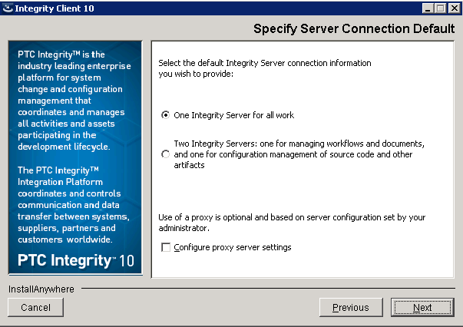

- Type in appropriate Host and Port Information below and Select ‘Next’;
  - Server Host name: S306A57
  - Server Port information: 7001.
NOTE:
- If you will be working on production projects that start with P1 you would select; S306A57 port:7001
- If you will be working on production projects that start with P2 you would select; S306A67 port:7001
- If you will be working on production projects that start with P3 you would select; S306A66 port:7003
- If you will be working on integration projects that start with P1 you would select; S3B4C05 port:7001
- If you will be working on integration projects that start with P2 you would select; S15C039 port:7003
- Select English and Select ‘Install’.
- Select ‘Done’ and close the browser.
- Start your Integrity Client.
- At the “Integrity 10” window select ‘Import ViewSet…’
- Enter the correct Host Name and Port and select ‘OK’.
- At the Select ViewSets to Import; select ‘MKS Source’ then select OK.
- Your Integrity Client is now installed, patched and ready for usage.
- ***Remember, when you close Integrity, you will need to do a File/Exit.

